

Talent Performance Metrics in the Entertainment Sector

Pooja Joshi & E25007



# Overview

In this report, we explore the performance metrics of talents in the entertainment sector by analyzing key data points such as popularity trends, ratings, language performance, and release patterns. The aim is to identify patterns and insights that can be linked to talent performance.

# Objective

* The primary objective of this analysis is to evaluate how various entertainment metrics reflect talent performance, focusing on factors like popularity, ratings, and release trends.

# Assigned Task(s)

* Analyze popularity trends over time.
* Investigate the relationship between ratings and vote counts.
* Examine language performance and its impact on popularity.
* Identify release trends and their influence on performance metrics

# Task Details

#### Task 1: Popularity Analysis

Status: Completed

Details: Analyzed trends in popularity scores over time to identify periods of increased attention for various media types.

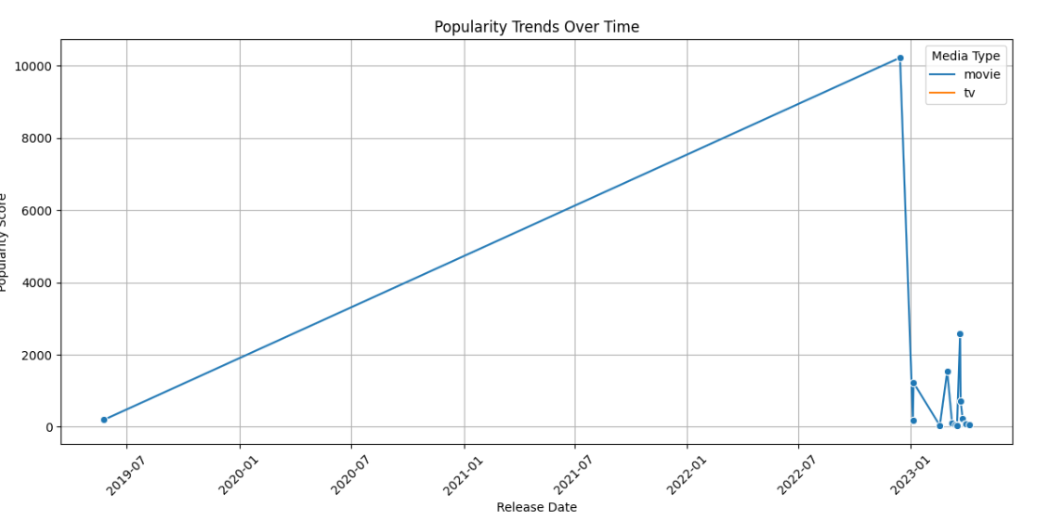

#### Task 2: Ratings vs. Vote Count

Status: Completed

Details: Created a scatter plot to explore the correlation between audience engagement (vote count) and average ratings.

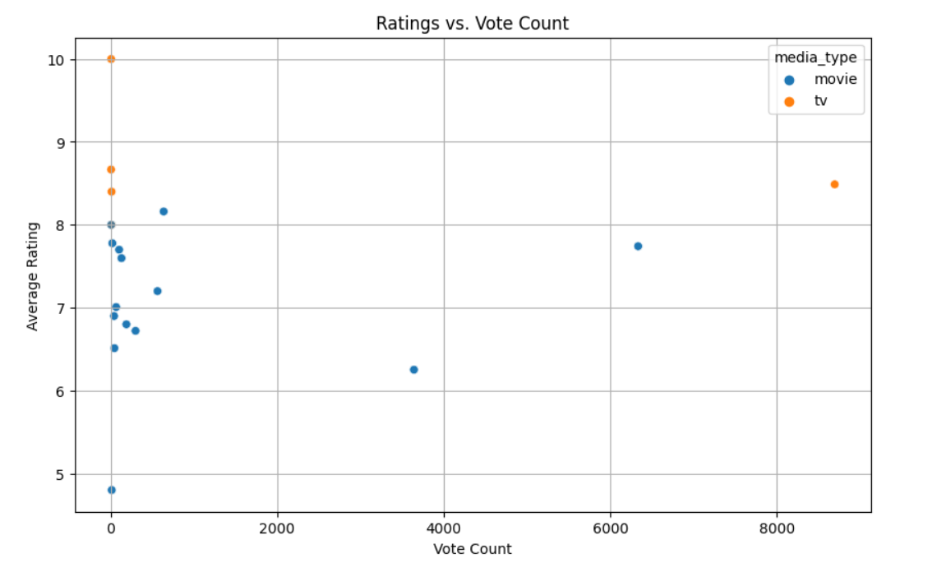

Task 3: Language Performance

Status: Completed

Details: Compared popularity scores across the top five languages, highlighting regional and language-specific impacts on performance

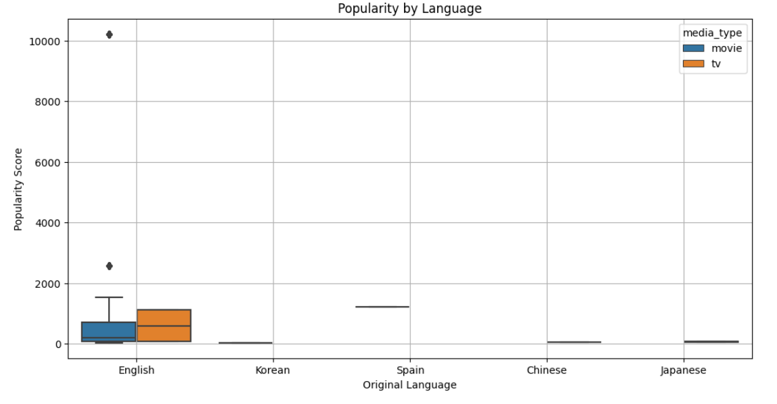

Task 4: Release Trends

Status: Completed

Details: Analyzed the frequency of media releases to identify patterns in release timing and its impact on popularity.

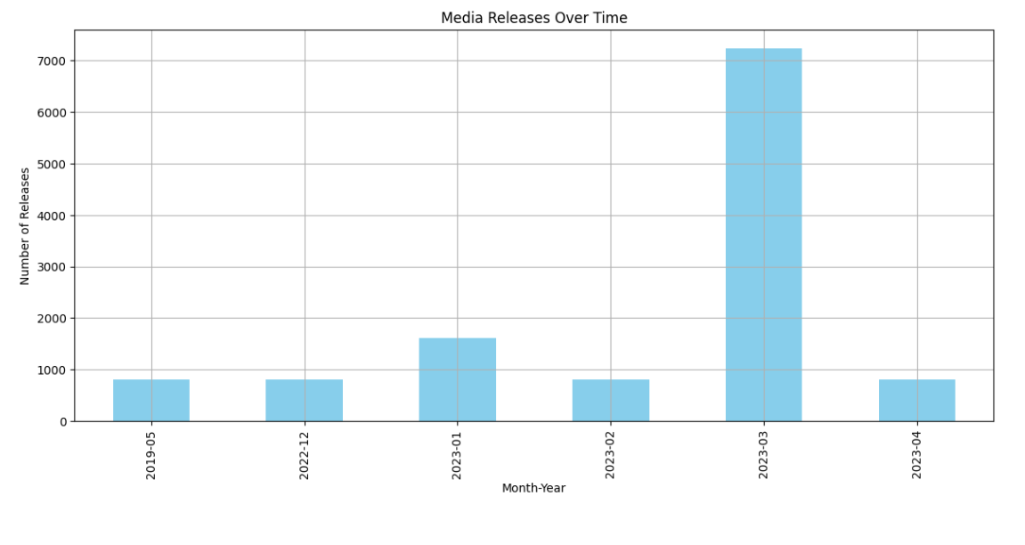

# Progress

Accomplishments :Successfully identified key trends and correlations between various performance metrics, providing insights into talent impact in the entertainment industry.

#### Metrics:

* + Increased understanding of popularity trends over time with clear visualization.
  + Demonstrated how audience engagement correlates with average ratings.
  + Identified language-specific performance insights.
  + Detailed release patterns contributing to performance analysis.

.

# Challenges and Solutions

* Challenges Faced:  
  Integrating talent-specific data with general performance metrics proved challenging due to data limitations
* Solutions Implemented:  
  Focused analysis on available data to extract the most relevant insights and recommended integrating talent data in future analyses for a more direct assessment.

# Next Steps

* Upcoming Tasks:
  + Integrate individual talent data to refine the analysis.
  + Expand metrics to include social media engagement and critical reviews.
* Goals:
  + Enhance the scope of performance analysis by adding new data sources.
  + Develop specific insights linking talents directly to media performance.

# Conclusion

Summary: The analysis provided valuable insights into media performance metrics and set the foundation for a deeper exploration of talent impact in the entertainment sector. Further work will focus on refining these metrics by incorporating more direct talent data.

* Acknowledgments: Thank the audience for their time and attention.



# Instructions:

1. Use Google Docs. Single Column
2. TNR stands for Times New Roman: B - Bold
3. Use images as required with proper references
4. Use charts, tables as per your requirement.
5. Number of Pages: 2 to 8 for each task report.